**INVENTORY REPLENISHMENT**

* **TO START   
  1.) Menu  
  2.) Transaction  
  3.) Inventory replenishment**

Transaction

2 1*1*

Inventory replenishment

33 1*1*

Menu

1 1*1*

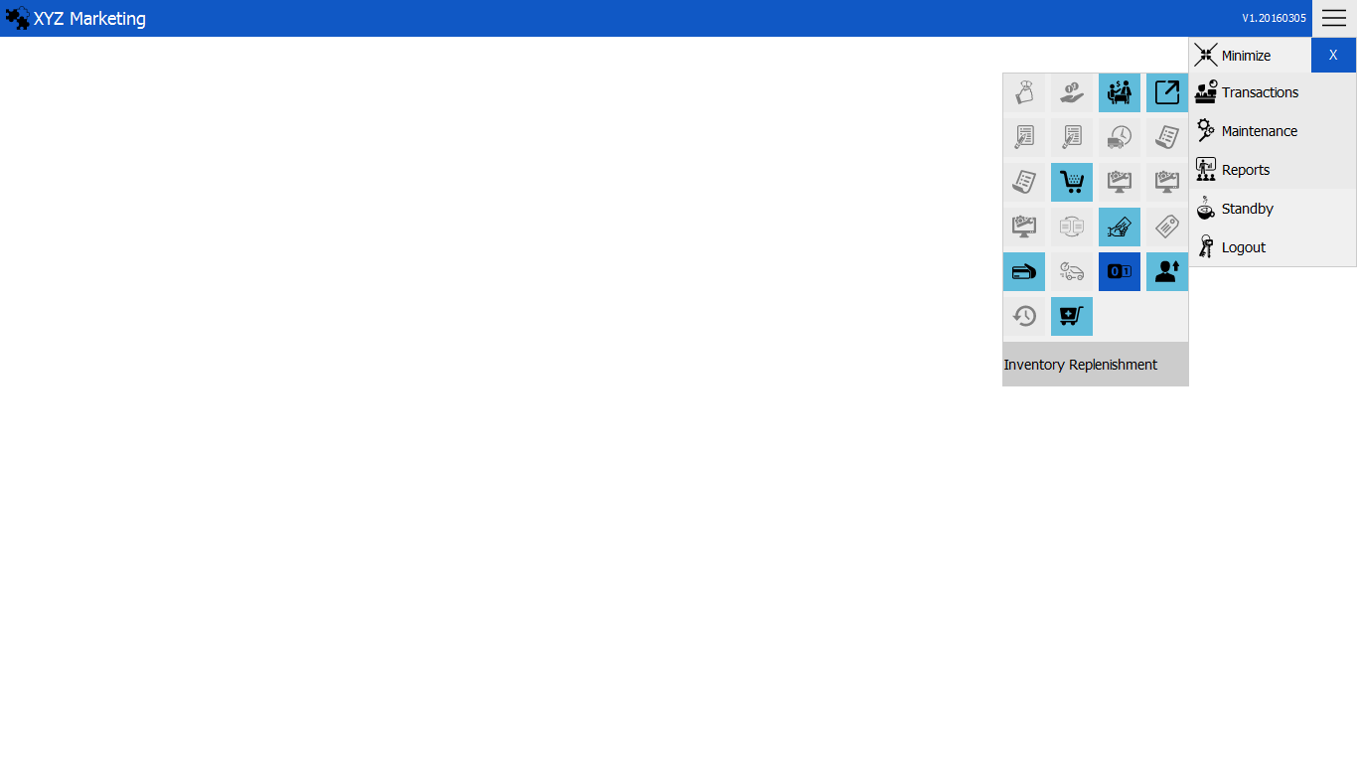

**TO REPLENISH INVENTORY   
1.) Select branch & location  
2.) Search  
3.) Replenish**

Replenish

3 1*1*

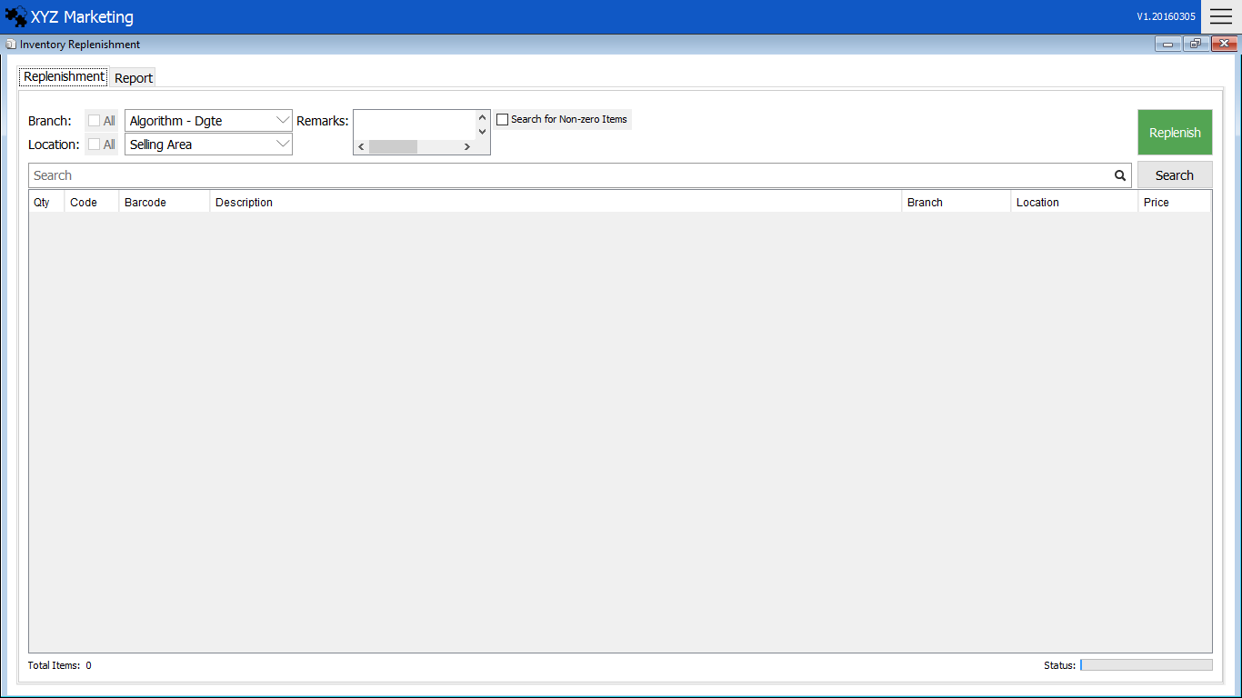

Branch & Location

1 1*1*

Search

2 1*1*

1. **Select branch & location**

Choose the branch and location of inventory wanted to replenish.

1. **Search**

Search to show the details of the inventory.



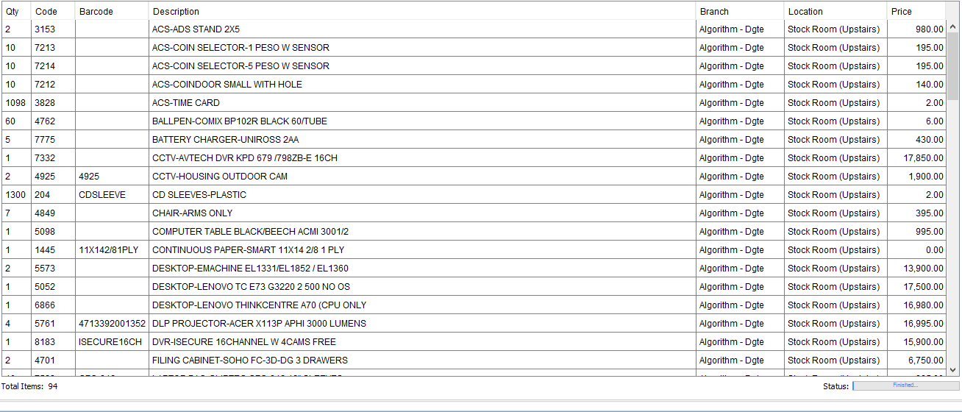

Quantity

The list of item is displayed after search.

You can also search for non-zero items in the inventory.

1. **Replenish**

Click the replenish button to replenish

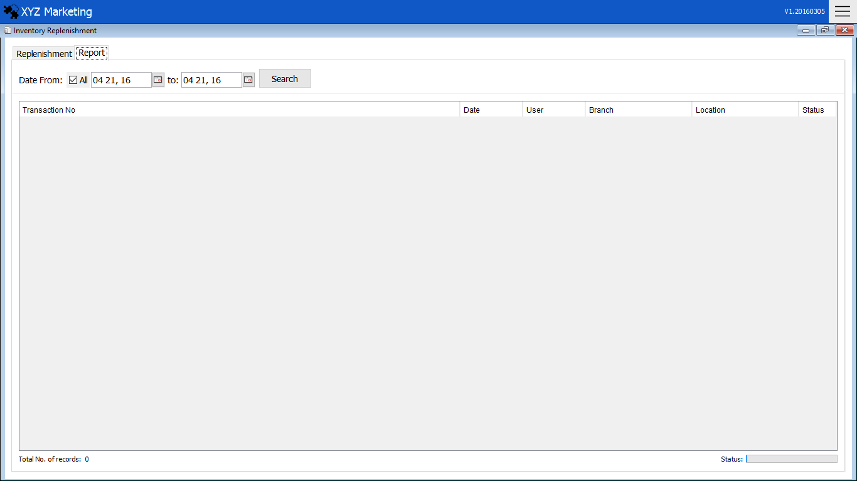

Search the inventory replenishment report by when it is replenished.

Date

1 1*1*

Report

You can also see the replenishments by clicking the report tab.

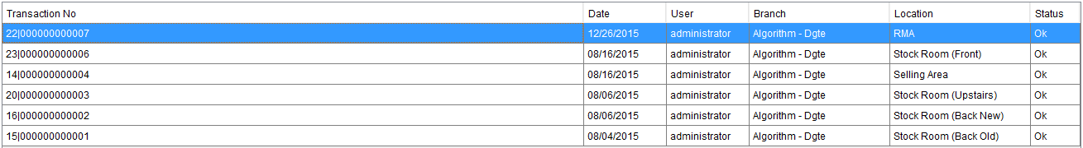

You can rollback the replenished inventory by just clicking it.

Rollback

